**Maths**

We are starting to learn about 2D shapes. Recap the names of 2D shapes that you already know.

Can you find any pictures of 2D shapes around your house?

Task: Can you make a picture using different 2D shapes?

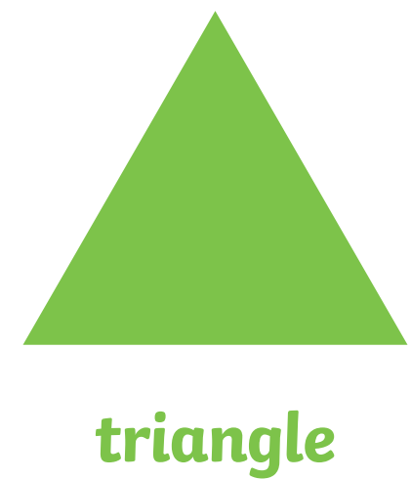Challenge: Can you write the names of the shapes?

What other shapes do you know?