**English**

In English this term, the children will be delving into book related to the solar system. Our writing this term will be based on the book called 'When We Walked on the Moon' by David Long and explores the fascinating story of the seven Apollo missions and the people involved in these . They will explore the dangers and triumphs that occurred during the missions and write about the settings within the text as well as character diary entries and poetry. They will be inferring how the characters are feeling to help them plan their writing. Throughout this term, the children will recap year 4 grammar skills, such as, expanded noun phrases and fronted adverbials.

**Mathematics**

In Maths, the children will be focusing on place value before moving on to addition and subtraction. This term’s learning will build upon concepts taught last year and will ask the children to apply their understanding to numbers up to a million as well as roman numerals. The children will be working with four-digit numbers using the column method to add and subtract. We will be developing their mental strategies and rounding skills

**Science**

In Science, the children will be exploring and learning about space. Children will learn to describe how the Earth and other planets move in relation to the Sun in the solar system. Our topic will include learning about the movement of the Moon relative to the Earth. Children will be able to explain day night by using the idea of the Earth’s rotation. The children will have the opportunity to discuss and use different methods of scientific working to solidify their knowledge.

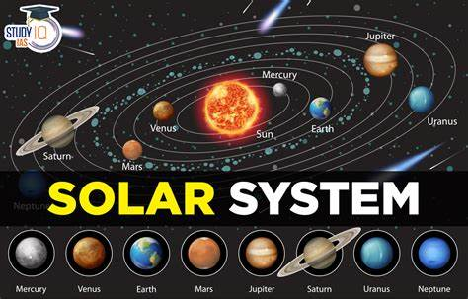

**Physical Education (PE)**

During our fitness lessons, the children will be learning about their pulse and how exercise affects this. They will be exploring a range of fitness skills and create some of their own circuits. Within gymnastics, children will learn to perform different balances within a routine. They will create sequences using mirrored and matched movements while developing their partner work. Children will use appropriate pieces of apparatus to perform counter balances and evaluate their performances.

**On The Move!**

**History**

This term, we will be learning about the city of Baghdad. The children will be exploring why and how the city was built, taking into consideration the wealth and prestige of the Islamic world. Additionally, children will explore the knowledge discovered by the Arab scholars of Baghdad which have contributed to the world they live in today.

**Geography**

The children will be learning about California and the water cycle. Through their growing understanding of where water comes from an is stored, the children will begin to understand why California is running out of water. By the end of the topic, children will be able to identify factors which affect the drought in California.

**Computing**

In computing, we will be developing the children’s understanding of coding. They will plan, create and debugging algorithms. They will begin to understand what a function is and how they work in code. Children will learn about different variable types and how they are used.

**Music**

Children will be exploring how music brings us together. Within this unit, they will be learning about melody lines and harmonies. Children will explore voices singing melodies and the instruments that are chosen to create harmonies.

**Art**

This term, the children will be learning about the artist Robert William and making links between William’s art pieces and their own. They will explore using the medium of sketching and painting to create their own landscape painting.

**Latin**

This term, children will be learning more about Latin tenses in verbs and identify similarities in words. They will explore Roman towns as well as travel in the Roman Empire.

**Religious Education (RE)**

Our focus in R.E. is God. We will expand upon prior knowledge and develop our understanding of God as well as linking this to bible stories.

**RHE**

We will be learning about the living in the wider world. The children will be exploring what it looks like to belong to a community and how they can help in their community. We will also be exploring the media and jobs that people do within the community